Presenter’s Notes
Session 2
How do we read? (LF2F Section 1) - The Beginning Reader (LF2F Section 2)

Resources required:
Short Video - ‘Learning as an adult’ - YouTube https://www.youtube.com/watch?v=8P7Y6lkZ_2U
Read Write Now video – The Language Experience Approach https://youtu.be/Ni7DQxWt2ZA
Access to Literacy Face to Face – including hard copies of Section 2, pp. 4 – 7 (Language Experience); 13 – 14 (cluster analysis) and 17 – 19 (Cloze)
Handout 1 – Sight Words (in resource folder)
Sheets of A4 paper (or similar), felt-tip pens (fine and thick) and scissors
Collection of newspapers, magazines, advertising flyers, information texts etc. (For Individual activity – Cloze)

Pre-reading for the Presenter: Literacy Face to Face
Section 1, pp. 3 - 8 (How do we Read?)
Section 2 (The Beginning Reader)

Overview of Session 2
10 mins. Recap of last week, slide 2
40 mins. How do we read? slides 3 – 24
45 mins. Teaching/ learning activities for the beginning reader - The Language Experience Approach, slides 25 – 31
20 mins. Coffee break
60 mins. More teaching/ learning activities for the beginning reader (Environmental print; sight words; phonics; cloze; just reading, slides 32-36)
5 mins. Close – Homework, slide 37
3 HOURS

PowerPoint | Instructions/Activities | Points to raise/Background information
Slide 1
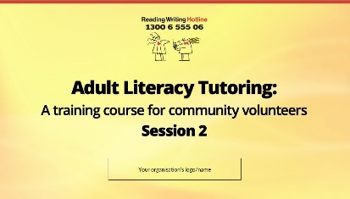
Slide 2  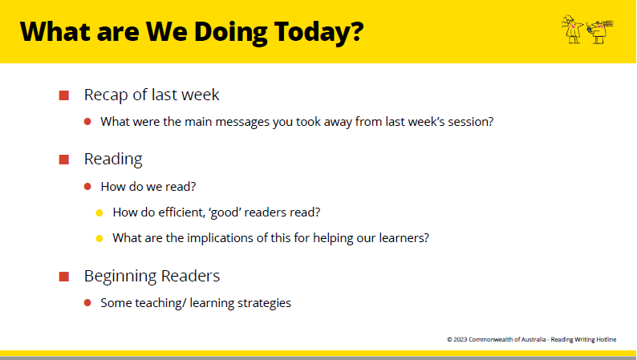 | Brainstorm - discussion  Recap of last week  Whole group discussion - Homework activity  What reading (including incidental reading) have you done during the week?  In this session we will:  - Talk about reading  - Writing and spelling are next session. | Stress the fragile nature of the learners and the need for encouragement, support and student-centred learning.
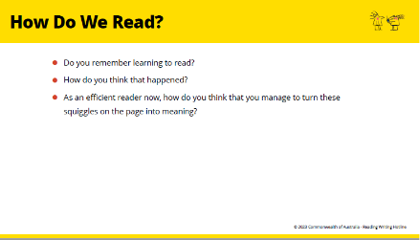  Slide 3 | HOW DO WE READ?  Brief discussion of these questions on PP. | Read LF2F, pp. 3 – 5 so that you can speak to this section.  Don’t spend too much time on this, as most people don’t really know how they learnt to read.  The question is designed to develop tutors’ questioning minds.  Make the point that:  - Reading is not just about knowing sounds, though that’s important.  - Many people who ‘know their sounds’ still have trouble with reading.  - We are now going to look at some other very important aspects of reading.
Slide 4  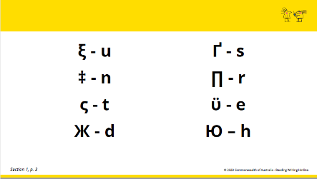 | Individual Activity  - Try to learn the sounds that  correspond to these symbols.  - Was it frustrating?  - That is how a literacy learner might feel. | Give instructions before you show this slide.  Give 30 seconds to learn as much as possible.
Slide 5  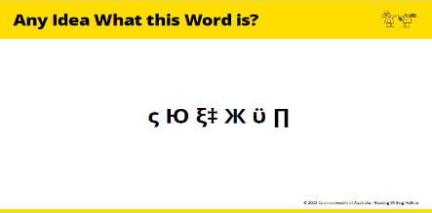 | - If you can work it out, don’t say it  aloud.  - Just look smug and wait for the others. | Most won’t be able to decode it – so don’t let them struggle too long.  If they can read it quickly, it is probably because they have looked at the manual in advance.
Slide 6  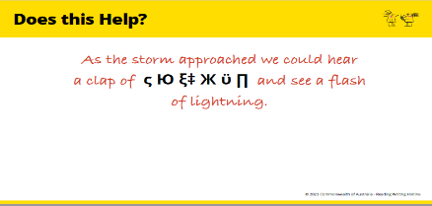 | Whole group discussion  - Does this help?  - How? | - Difficult to read the word by itself  - Easier to read it in a whole sentence  - You use the rest of the sentence to predict the word.  - This is a key aspect of reading.
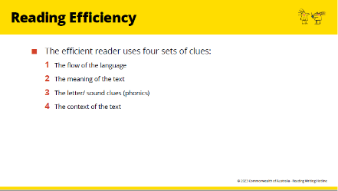  Slide 7 | - Now we are going to look more closely at how that works.  - We will look at how we use these clues when we are reading.
Slide 8  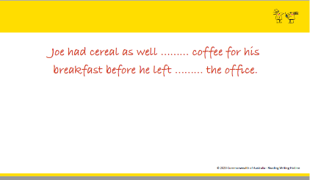 | Whole group activity  - Fill in the blanks in this sentence.
Slide 9  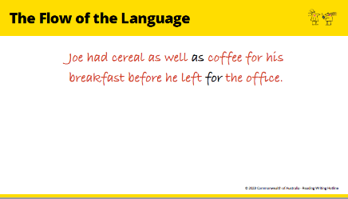 | How did you know which words to put in?  - They just sounded right.  - The sentence flows as we expect it to | The flow of the language is the grammar, or word order.  An NESB or English as a Second Language learner might not be able to do it because they don’t have a feel for the flow, or grammar, of the language.
Slide 10  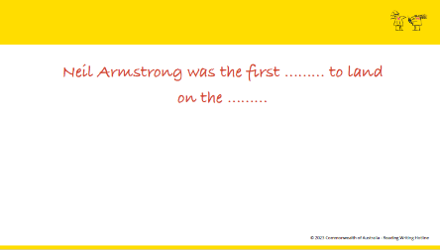 | Whole group activity  Fill in the blanks in this sentence.
Slide 11  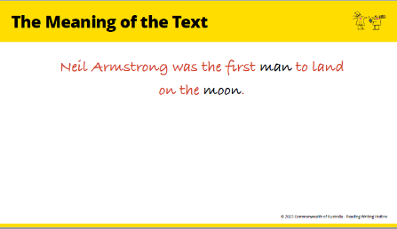 | How did you know which words to put in there?  - You probably knew about the subject.  If you didn’t, it would be hard to guess the right words.  - We can predict on the basis of our feeling for the flow of the language  and our knowledge of the subject. | - If you know English and know who Neil Armstrong was, you could read without having to focus on every word.  - This is prediction. Efficient readers predict, or guess, much of what they are reading.  - They do not look carefully at every letter of every word. They just take in a sample of the print to help their predictions and to confirm that they are right.
Slide 12  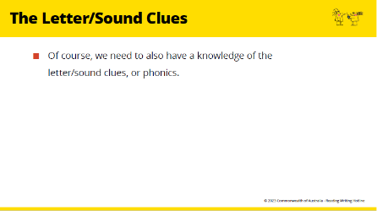 | The other set of clues we use are the sound/ letter clues or phonics | - We also need to know something of the possible sounds made by the letters, or the phonics.  - This is particularly important for beginning readers.  - We will talk more about it later.  - Now we are talking about the other skills that support development of that phonic knowledge.
Slide 13  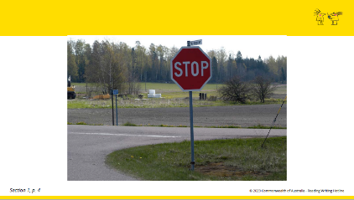 | Whole group activity  How could you read this word in the  rain or fog if you can’t see the letters clearly?  - You know the shape and colour of the sign, where it is placed.  - That is, we can predict from the context of the text. | - The more clues there are to suggest what the word might be, the easier it is to identify the sounds made by the letters.
Slide 14  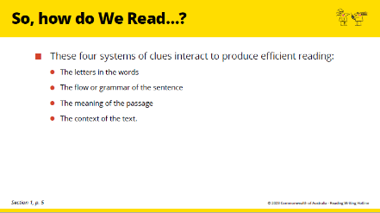 | To summarise,  - These four sets of clues interact and support each other. | So learning about letters and sounds in isolation from real texts makes the learning difficult.
Slide 15  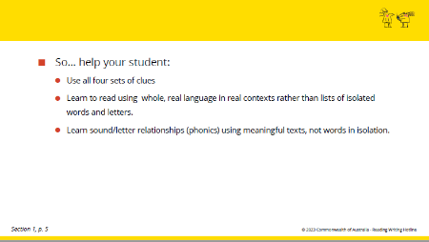 | ‘Sound it out’ is not the only answer.
Slide 16  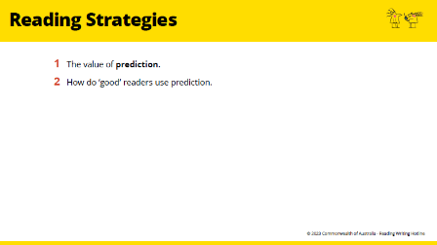 | - Now we’re going to look at how these systems of clues work for us as ‘good’ readers.  - We are going to look at the strategies we use. | Read LF2F, pp. 5 – 8 so that you can speak to this section.
Slide 17  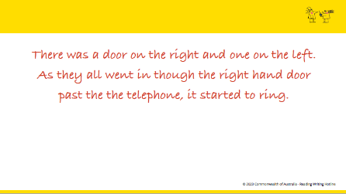 | Activity  - Read this silently. | Only give a few seconds reading time before you move to the next slide.  LF2F section 1 pp. 5 – 6 has further explanation of the value of prediction and its implications. Read it carefully in advance and explain in your own words.
Slide 18  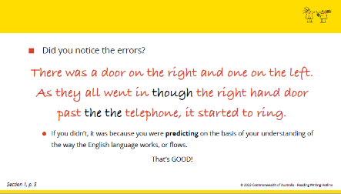 |  | - Although that passage was specially written to make it highly likely that you would ‘make a mistake’, you undoubtedly ‘make mistakes’ in your reading constantly as all good readers do.
Slide 19  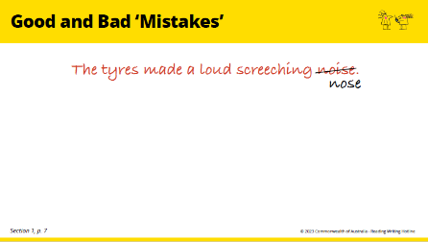 | What are some of the differences  between a good reader and a weaker reader?  - Is it just that the weaker reader  ‘doesn’t know their sounds’?  - It is much more complicated than that.  - For example, imagine that one reader has read this sentence this way:  - This is a typical mistake that people who are not confident readers make. | LF2F section 1 pp. 7 – 8 in advance and explain in your own words.  - The reader who read ‘nose’ has not used the meaning clues. The reader who read ‘sound’ has overlooked the letter/sound clues.  - This second reader missed these clues because their mind was on the meaning of the passage.  - They already had a pretty good idea what word might be there, so they had no need to look carefully at the letters.
Slide 20  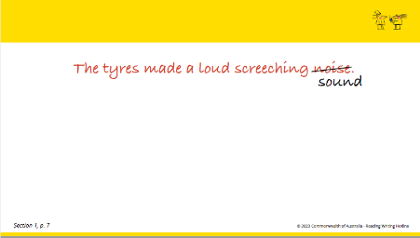 | Now imagine that a second reader reads the sentence this way:  - ‘Sound’ looks nothing like ‘noise’ so it would seem to be a very careless mistake. However, it makes sense and shows that the reader is thinking of the meaning of the sentence and is predicting on the basis of meaning.  - This is in fact what all good readers do. It is therefore a ‘good’ mistake.
Slide 21  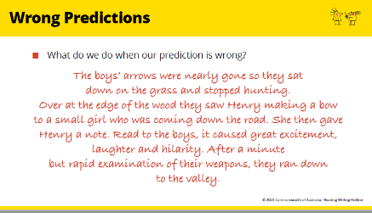 | Activity  - Read this passage to yourself.  - What was going on in your mind at certain points in that passage? | Only allow about 30 seconds reading time.
Slide 22  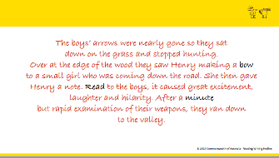 |  | - One of the marks of a good reader is that they know when they make a prediction which doesn’t make sense.  - You undoubtedly ‘make mistakes’ in your reading constantly as all good readers do, so try to become conscious of your reading behaviour and you will realise that you do this often.  - Whilst beginning readers need to pay more attention to the letters and sounds, once your student is reading a little more confidently, then the implications of what we have just looked at are really important for you to keep in mind.
Slide 23  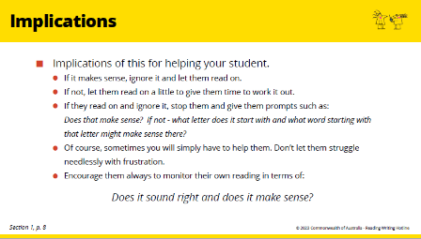 | - This is a summary of the implications of understanding how we read. Keep  these points in mind when you are helping adults who already ‘know their sounds’ but still need to improve their reading.
Slide 24  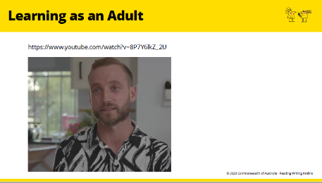 | Short Video - ‘Learning as an adult’  Brief discussion  What interested or impressed you about Mike’s story? |  | - This is a discussion between one of the students (Mike) in the ‘Lost for Words’ program, and his teacher in that program.  - Mike was what we might call a beginning reader.  - He talks about learning as an adult.  - NB At the end of the discussion he talks about the value of prediction when he is reading. Notice how he talks about that.
Slide 25  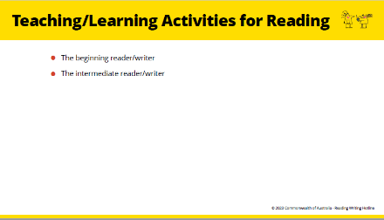 | Now we are going to look at some teaching/learning activities that we are going to suggest for you to help your learner.
Slide 26
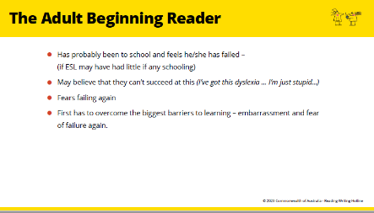
Slide 27
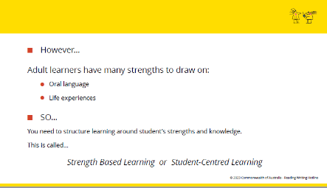
Slide 28  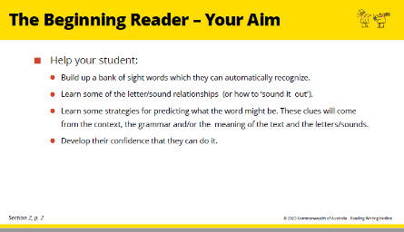 | THE BEGINNING READER – SOME LEARNING ACTIVITIES  Brief discussion  Recap briefly what was covered in the  How do we read? part of this session, especially the need to learn using all four sets of clues. (Section 2, p. 2)  Now keep those concepts in mind as we look at some activities or learning strategies to help the beginning reader.
Slide 29  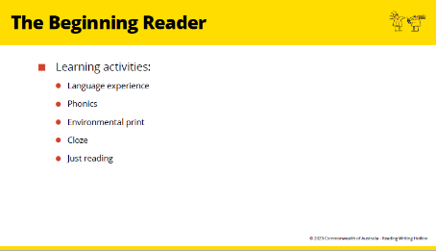 | These are some teaching/ learning activities that are useful for beginner readers, and that we are going to look at.
Slide 30  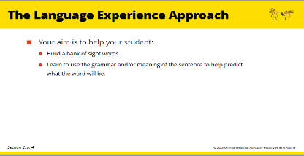 | The Language Experience Approach  Make sure tutors have a copy of  this section of LF2F (Section 2, pp. 4 – 7), and go through this together. |  | Read Section 2, pp. 4 - 7 in advance so you can speak to this.
Slide 31  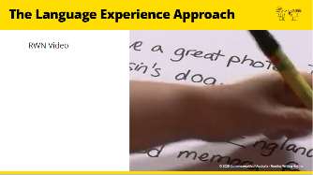 | Video  Watch RWN video demonstration of Language Experience  Pair Activity  - Break the group in pairs to practise the activity.  - Each pair needs a piece of paper, a felt-tip pen and a pair of scissors.  - One member of each pair will be the tutor and one will be the student.  - The student will tell the ‘tutor’ something about themselves.  - Don’t spend too much time over this discussion phase of the activity, and don’t try to pretend to be a student.  Just give the ‘tutor’ a few sentences to start to work on.  - Then go through the steps suggested. |  | If you have time, they can swap roles and do it again.  Practising these activities will make tutors feel less anxious about it when they are with a real student.
Coffee Break

Slide 32  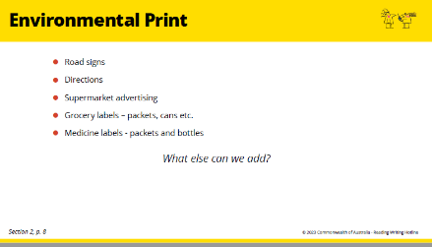 | Environmental print – sight words  Can we add to this list?  (Think about the earlier discussion about your homework task.) |  | Read Section 2, pp. 8-9 in advance so you can speak to this.
 | Handout 1 – Sight Words  Look through and briefly discuss the handout.  For next week:  - Find a supermarket ad in a newspaper,  a supermarket or hardware store brochure etc.  - Read through LF2F, Section 2, pp 8 – 9 and be ready to practise teaching your ‘student’ some words next week. |  | - These worksheets are an example of the sort of activities you can do with words from signs, labels, advertisements etc.  - When learners have done these matching and copying exercises, the tutor writes the words separately on word cards for the learner to read without  the support of the picture.  - This moves from the support of the pictures, so the learner can guess the words, and maybe the tutor’s prompting, to recognizing the words by themselves as sight words.  - Teachers call this scaffolding the learning, then you slowly remove the scaffolding.
Slide 33  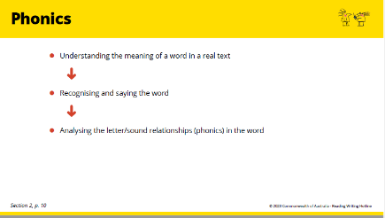 | Phonics  Beginner readers need to pay more attention to learning phonics than more efficient readers. However, in a student-centred approach, we don’t start with teaching phonics. |  | Read Section 2, pp. 10 – 16 in advance so you can speak to this.  In particular, present pp. 10 – 12 in your own words.  - We don’t assume the adult learner is an empty slate.  - We build on what the learner already knows.
 | Group Activity  Handout 1 – Sight Words  Introduce Cluster Analysis (Sect. 2 p. 13 -14)  Together work through the ‘ent’ cluster in enter entry, entrance. (Handout 1 above).  Pair Activity  - Ask tutors to work in pairs.  - Each one chooses one of the letter clusters from the list of common letter clusters (Sect. 2, p. 14)  then work through the suggested routine to teach the cluster to their partner. |  | You will be modelling the role of tutor here.
Slide 34  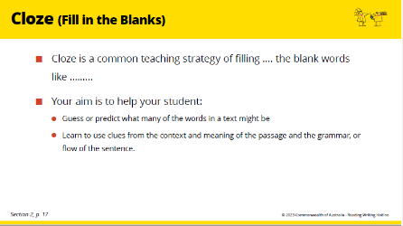 | Cloze  Individual Activity  discuss each word: Ask tutors to  read Sect 2, p. 17 and do the cloze  exercise on p. 18.  Group discussion of each word  - How did you know which words to put  in there?  - Are they clues from your knowledge of the world?  - Are they clues from the flow of the language?  - Do the clues come before the deletion?  - Do you have to read on to get the clues after the deletion?  Individual Activity  Together, read pp. 18 – 19 Making an  oral Cloze Exercise  - Give tutors a page or passage  from a newspaper or magazine. The passage should be about two paragraphs long. They also need a thick felt-tip pen.  - Make a cloze exercise for your partner.  Pair discussion  - Then exchange exercises with your partner and discuss the difficulty/ ease of your deletions. |  |  | Read Section 2, pp. 17 – 19 so that you can introduce this in your own words.  Cloze is a really useful learning activity so it is worth spending a little time on it so tutors feel comfortable about using it when the time comes.
Slide 35  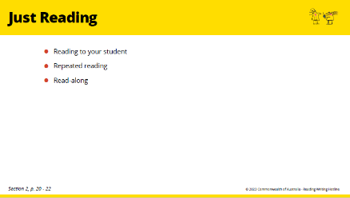 | Just Reading |  | Read Section 2, pp. 20 - 22 in  advance so you can speak to this.
Slide 36  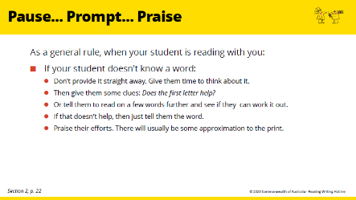 | Brainstorm - Discussion  ‘Pause … Prompt … Praise’ is important advice.  - Why are these points important?  - Relate them back to what we learnt about how we read.
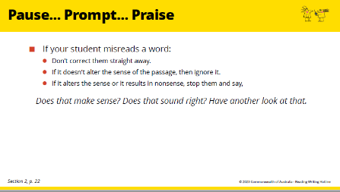
Slide 37

Slide 38  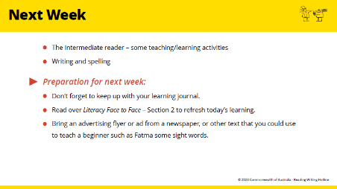 | CLOSE - HOMEWORK  Whole group discussion  Read together Fatma’s case study  (Section 2, p. 23)  Discuss what environmental print someone like Fatma might need help with.  Remind tutors to look more  carefully at Handout 1 – Sight words as  an example of how signs, labels etc can  be used to help beginner readers.  For Homework  - Find, and bring to the next session a  text that you might be able to help Fatma with (e.g. copies of direction  signs downloaded from the internet, product labels, supermarket advertisements, advertisements in magazines).  - Be ready to practise teaching your ‘student’ some words from your text next week.

