Presenter’s Notes
Session 1
Program Introduction – Who are our students? - Adult Learning (LF2F Section 1)

Resources required (from the Resource Folder):
Download and print copies of Sue’s Story and Helen’s story (sufficient for half the group each) AFSOS-for-download.pdf (readingwritinghotline.edu.au)
Video: Jo Medlin talks about adult literacy and the students we support. https://www.youtube.com/watch?v=TcAYFWzZAQw
Video: Grahame’s story: an adult learner’s perspective https://www.youtube.com/watch?v=4wf3ScxJoFA

Pre-reading for the Presenter: Literacy Face to Face
Section 1, pp.1 – 2 and 9 – 14
Section 7, pp. 1 – 4 (Skim read the remainder of that section)
Section 8, pp. 1 – 7

Overview of Session 1
20 mins. Introductions: Introduce program and tutors, slides 1 – 4
70 mins. Our students, slides 5 – 12
20 mins. Coffee break
50 mins. Adult Learning, slides 13 – 21
20 mins. The tutor’s roles and responsibilities – Close – Homework, slides 22 – 26
3 HOURS

PowerPoint | Instructions/Activities | Points to raise/Background information
Slide 1  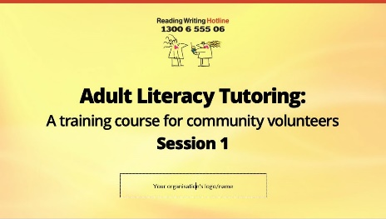  Don’t forget to insert your organisation’s logo to this slide | INTRODUCTION  - Welcome  - Acknowledgement of Country  - Introduce yourself  - Any housekeeping  - Brief introductions of tutors | - This program has been developed by the Reading Writing Hotline which is a Commonwealth Government funded organisation, and is being sponsored by [your organisation].  - Add brief information about your program. E.g., how the students are ‘recruited’ and what the role of the co-ordinator is, where students & tutors meet, etc.  - There is an opportunity for you to discuss details of your program in greater detail at the end of the session (Slides 22- 23) and in the final session of the program.  - Try to keep tutor introductions brief. Perhaps specify ‘A few sentences..’  - There will be plenty of important ‘getting to know you’ time later.
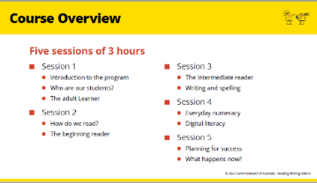  Slide 2 | Brief overview of the course
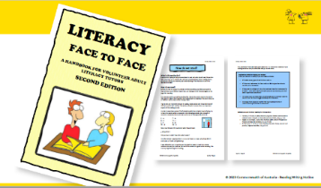  Slide 3 | Introduce Literacy Face to Face | - The course closely follows this handbook  - All tutors will need access to at least the online copy.  - If relevant, detail the arrangements you have made for tutor access or printing of hard copies.
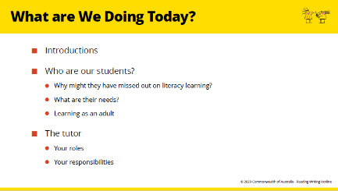  Slide 4 | What are we doing today?
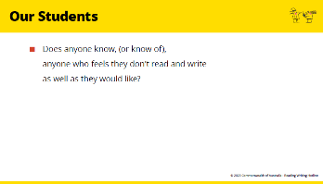  Slide 5 | WHO ARE OUR STUDENTS?  - Does anyone know, (or know of) anyone who feels they don’t read and write as well as they would like?  - Would they feel comfortable telling us just a little about them?  - Of course, without naming them or telling us anything that might identify them?  - And do you have any idea why they might not have developed these skills when they were young? | - Try to keep anecdotes brief and relevant.  - If nobody wants to offer any stories, then move quickly on to the next activity.
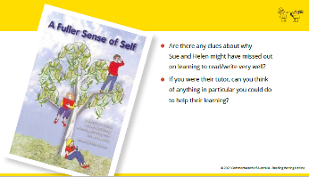  Slide 6 | Individual reading  - Participants work in pairs.  - Give one member of the pair a copy of Sue’s story, and the other member a copy of Helen’s story.  Pair discussion  Tutors take turns telling their partner about their person and discuss the questions on the PP.  Whole group discussion  What do Sue and Helen’s stories tell us about:  • Why might people have missed out on learning and how we can help? | - The stories of two adults who have improved their literacy and are reflecting on their learning.  - When they had been going to classes for a little while, they were interviewed and their stories written down in a wonderful little book called “a Fuller Sense of Self”.  - “A fuller sense of self”, was what one of the adults said she had gained from improving her literacy.  - The book is free to download if tutors want to read more of these student stories. (Link on the Reading Writing Hotline website)
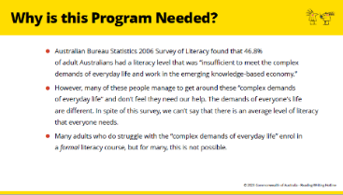  Slide 7 | Why our program?  Brief discussion of points raised by these statements | Some reasons to choose a volunteer tutor course:  - There is no formal adult literacy course available in their area, or at an appropriate time.  - Many don’t have the confidence to go to a group course, so they need the emotional safety of one-to-one tutoring.  - School was a very negative experience, and formal adult classes remind them of that so they avoid it.  - Starting with a volunteer tutor is often a good first step.
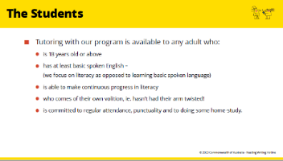  Slide 8 |  | - You may need to change this list to reflect your organisation’s policy.  - The reason for the “need to make continuous progress” stipulation is that if a student has an intellectual disability which does not allow them to make progress, then both the tutor and student will become frustrated. Such students will need professional assistance beyond the strategies suggested in this program.
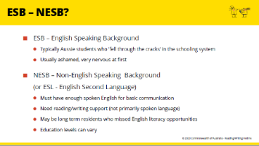  Slide 9 |  | - You may note that some organisations use other terms including  - CALD Culturally and Linguistically Diverse  - EALD English as an Additional Language or Dialect
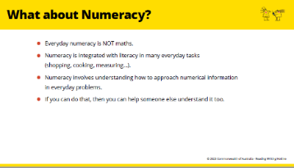
Slide 10

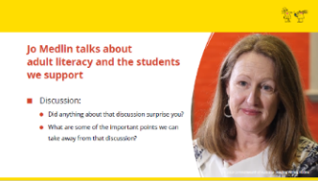  Slide 11 | Video:  Jo Medlin talks about adult literacy and the students we support.  Whole group discussion:  - Did anything about that discussion surprise you?
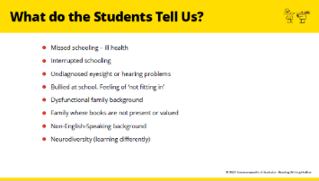  Slide 12 | Whole group discussion  - This is a list of some of the reasons some adults have had trouble with learning to read and write.  - Were these all covered in that video, or were there other reasons or examples given in the video that we could add to this list? | - As you read through this list, try to relate the points back to comments made, or anecdotes related in the video.
Coffee Break
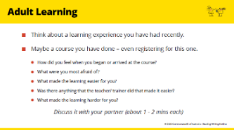  Slide 13 | ADULT LEARNING  Pair discussion  Break the group into pairs to discuss questions on PP.  Whole group discussion - feedback  What were the most interesting or important points that came out of your discussions?
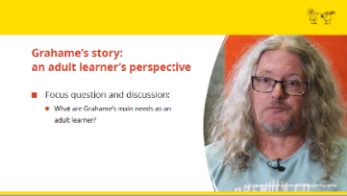  Slide 14 | Video  Grahame’s story: an adult learner’s perspective  Focus question and discussion:  What are Grahame’s main needs as an adult learner? | - There are a number of important aspects of the learning process for adults which are different from the learning process for children.  - As we listen to Graham’s story (and remembering Helen and Sue’s stories), we can see that they wouldn’t succeed in a learning situation similar to the one they failed in as a child.
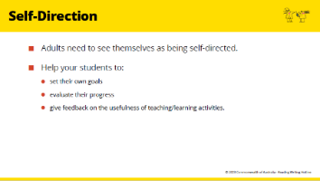  Slide 15 | Presenter led discussion  Very brief discussion of each of these slides to focus on the question:  Can you think of any examples from your own experience of learning or from the stories of the adult students we have heard about, to illustrate these points? | Section 1, pp 9-11  Read in advance so that you can speak to, and explain these slides.  - These are some important messages that we can learn from theories of adult education.  - They relate to our adult attitudes and emotions as learners, rather than the neurological and cognitive processes of learning which are the same as, or similar to, the learning process of children.
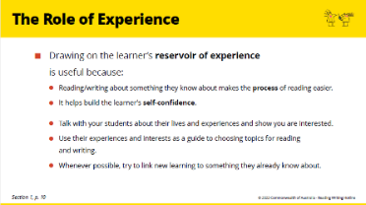
Slide 16

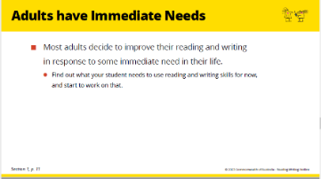
Slide 17

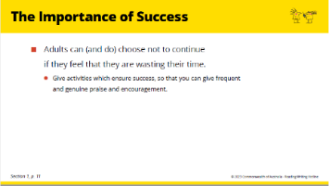
Slide 18

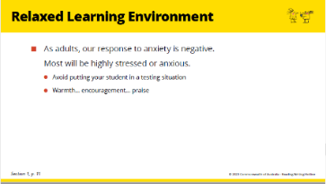
Slide 19

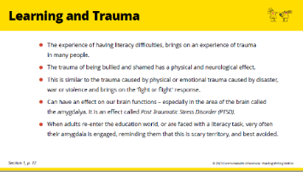  Slide 20 | Remind the group of Sue’s story of her first session. “I would sit with my head bowed down. I wouldn’t look at anyone. I was too scared to answer questions for fear of being wrong. I was so frightened. I remember the first day very clearly .... They got me to write the word CAT. I remember I shook so much you would look at that writing and think that a small child had written it . When I started I shook, and I shook, and I shook. I sat there the whole time with my head down.”  And another quote from one of the ‘Fuller Sense of Self’ stories:  “In high school nothing really changed. I know when I was asked to read I would get all sweaty and clammy. I would feel the anxiety rise up in me. I would know they were going to pick me and I would head straight for the door.” Megan’s Story in ‘A Fuller Sense of Self’.  And for most students that anxiety takes a long time to go away (if at all). | LF2F Section 1, p. 12 Read in advance so that you can speak to this.  Whilst the other principles of Adult Education are applicable to all (or most) adult learning situations, this consideration of learning and trauma is particularly relevant to adult literacy students, and highlights the last principle mentioned, that is, the need for a relaxed learning environment.
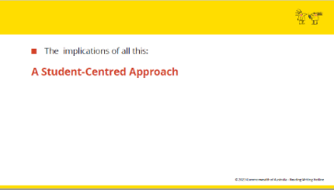  Slide 21 | A student-centred approach | - Adults come to us with a wide range of needs, and of literacy and educational backgrounds,  - So a student-centred approach begins with responding to the individual student’s needs; not presenting them with a one-size-fits-all program.  - This is the approach that has been most widely adopted in the teaching of literacy and numeracy in Australia and overseas.  - Before tutors meet their student, the co-ordinator will have done an assessment of their needs and be able to suggest some teaching/ learning activities.  - However, tutors will need to keep their students’ needs, goals and interests in mind during the tutoring sessions.
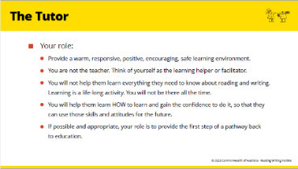  Slide 22 | THE TUTOR’S ROLES AND RESPONSIBILITIES | - Now that tutors understand a little about the challenges that most of these adults face, they can be clearer about the type of help that they, as non-professionals can offer.  - Whilst none of us can make absolute commitments of this sort, it is important to understand how fragile some of these learners are, and how important the relationship between tutor and student is.  - Tutors are able to let the coordinator know if they prefer not to tutor a particular person who may be suggested to them. They can also specify whether they prefer same/different gender or youth/ older person etc.  - You might need to add more information here if there is anything specific to your organisation.  - For information about Boundaries to the Tutor’s Role, see Section 8 p. 7.
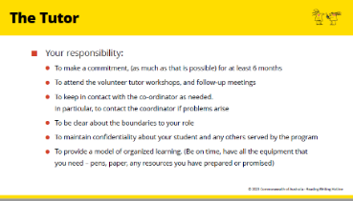
Slide 23

Slide 24  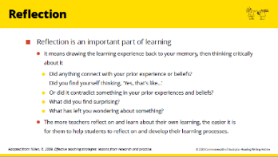 | REFLECTION | - An important part of learning is reflection on your learning experience. Drawing something back to your memory helps you to remember it, and thinking critically about it helps it become part of your world understanding and connects it in some way to what you already know and understand.  - Thinking critically means asking yourself, for example:  -What does this mean to me?  - Did anything connect with my prior experience or beliefs?  - Did I find myself thinking, ‘Yes, that’s like.. ....’  - or did it contradict something in my prior experiences and beliefs?  - what did I find surprising?  - what has left me wondering about something?  (By the way, thinking critically doesn’t mean being critical in a negative sense. It just means thinking deeply about something.)  - Later sessions will emphasise that encouraging our students to reflect on their learning is an important part of their learning program. So it is important for the tutors to get used to reflecting on their own learning.
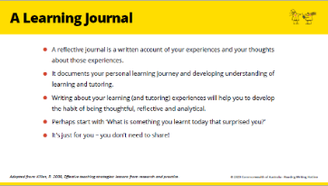  Slide 25 |  | - Keeping a learning journal (for tutor and for learner) is a very good way to aid this reflection.  - It doesn’t have to be an onerous duty. We aren’t suggesting you write whole essays each week (though you can if you want to), but just starting with a few sentences would be a way to get into the habit.  - And remember, it is just for you to read. You don’t have to share it.
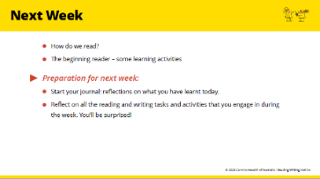  Slide 26 | NEXT WEEK

